## ZERO OVER HEAD LOOP FIR PROCESSOR

**Sourindu Chatterjee**

**Department of Electrical and Computer Engineering, Florida State University**

**APRIL 6, 2016**

## WEEKLY REPORT



Period 5-6 :

Construction of different states associated with FIR processor stages.

Simulation of ZOL FIR processor for 5 generic and 3 dynamic filter length.

Creating better test data and working towards creating a test bench.

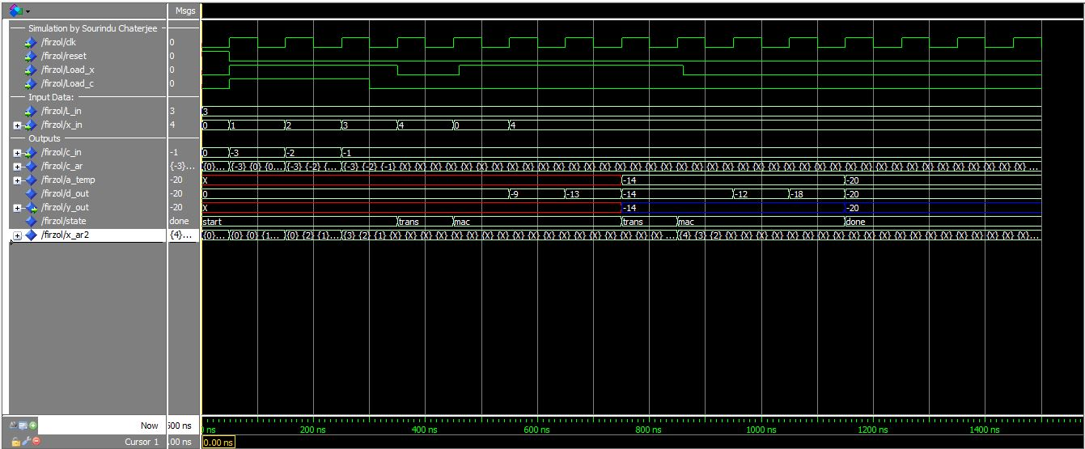

Please zoom in the picture to see results..